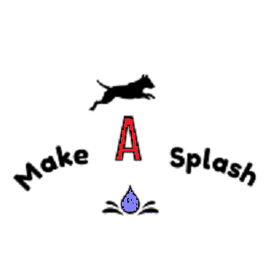

Be A Champion Day!

Monday 6th May 2024

At the Grange Equestrian Centre, Okehampton

Join us for our Championship style agility show – not just for Grade 7 but a chance for all grades to participate in the champ class experience!

2 runs over a jumping course followed by 2 runs over an agility course (best score in each round to count) with the top 50% of dogs going through to the champ final.

This event will take place in a fenced paddock on grass. There maybe horses in the adjoining paddock and the ring is on a slope.

Entry fee £15 per dog. Entries are limited. Grades will be split 1-3 & 4-7 but only if sufficient entries Entries close Thursday 2nd May 2024.

Anticipated order of the day

10am start Jumping 1-3 followed by 4-7 then Agility 1-3 followed by 4-7 then final for all grades.

Rosettes will be awarded to at least 4th place in the jumping and Agility rounds (combined heights) with Champion and Reserve champion being awarded in the final.

**Rules**

No food to be carried in the ring.

A silent toy may be used in the ring without penalty.

Dogs must run in their drawn order – just as they would in a real champ class.

Dogs may run at any height but must declare the height they wish to run when entering.

Dogs must be over 15 months of age



ENTRY FORM – Entries Close 2nd May 2024

Dogs Name ………………………………………………………….

Handlers Name ………………………………………………………….

Height to run (Delete as nec) Large Intermediate Medium Small

Dog KC grade ………………………………………………………….

Handler Address …………………………………………………………..

……………………………………………………………………………………..

………………………………………………………………………………………

Handler email address – please write it clearly your r/o will be sent here ……………………………………………………………………………..

Handler phone number …………………………………………………..

Entry forms to Debs Colling, Great Widefield Cottage, Northlew Road, Okehampton, Devon, EX20 3DA or emailed to [widefieldpets@aol.com](mailto:widefieldpets@aol.com)

Payment details will be sent on receipt of entry. Full payment will secure booking.